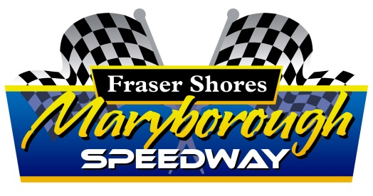

P O Box 194, Maryborough Qld 4650
Email: admin@maryboroughspeedway.com.au
Phone: (07) 4121 5677 ABN 95 067 015 882 ACN 009 713 820

DRIVERS NAME
ADDRESS
 |  |  |  |  |  |  | P/Code
PHONE No ‘s | HOME |  | WORK |  |  |  | MOBILE
EMAIL
MEMBER OF | CLUB |  |  |  |  | Speedway Aust # |  | EXP /
MAKE / MODEL |  |  |  |  |  | RACING #
SPONSORS
DATE OF MEETING: / / |  |  |  | NOMINATED DIVISION:

PLEASE COMPLETE: NB - Name and Address of driver or team owner must be completed in full above.
- Do you declare you’re racing activities to be a hobby? Yes No (If yes go to Q4)
- Do you have an ABN # Yes No
- If yes are you registered for GST Yes No
- TRANSPONDER # OWN / HIRE (Hire Fee applies)

SCRUTINEERING:
All cars must be available for inspection between 1 pm and 3:30pm. Cars will not be accepted after 3:30pm, unless by prior arrangement by calling MSCC. Racing will commence at 4 pm SHARP All cars must comply with 95 D.B.A.
NB :* Prize, Tow, Travel or Appearance Money will be paid inclusive of GST. If a competitor has an ABN and does not provide number and does not declare their racing to be a hobby, withholding TAX of 48% will be withheld and remitted to the TAX Office.
*Any prize, tow, travel, appearance money unclaimed within 14 days shall become disputed prize money as per Australian Speedway Racing Rules 4.23.12. There shall be no grounds for return after 14 days of the said meeting.
NOMINATIONS:
NO dual nominations - ie: two drivers in one car in the same division /one car in two divisions on the night
E mail maryboroughcar@bigpond.com or mailed to PO BOX 194, MARYBOROUGH 4650
On line - www.maryboroughspeedway.com.au .Go to forms page and click on online nominations.
Nominations close Sunday week prior to race meeting date at 5:00 PM (NO EXCEPTIONS).
All nominations received/ accepted after this time will be deemed a late nomination and start rear of field.
INDEMINTY CLAUSE I, the undersigned DO HEREBY AGREE to indemnify and keep the Promoter, Landholder, their Agents and Officials from all actions, suits, claims and demands for damages or any other expenses what so ever arising out of, or relating to or from the use by me on the Maryborough Sporting Car Club circuit and it’s surrounds for the purpose connected with practice and / or competitive racing or trials and or motor events. I further agree that I will promptly carry out any reasonable instructions from any Official of the Maryborough Sporting Car Club and will not in any way, do or suffer to be done, anything contrary to the regulations of the said club. The DRIVER shall be responsible for his or her Pit Crew according to the racing rules and regulations. I also understand that the nominated driver and his/her pit crew may appear in visual media (i.e. photographs, video footage) that is undertaken inside this speedway complex and that it remains the property of the media personnel involved; I also agree to any visual media involving the nominated driver and his/her pit crew to be used by the associated media personnel and/or Maryborough Sporting Car Club. The promoter/club has the right to refuse any nomination.
SIGNED by OWNER / DRIVER |  | DATE
SIGNED by Parent/Guardian | (JUNIORS ONLY) | DATE

